BAOMS Mini Grant Report
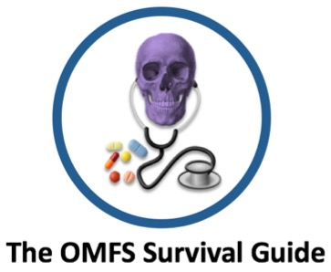

The OMFS Survival Guide is a team of dual-qualified trainees and 2nd- degree medical and dental students that deliver interactive case-based teaching aimed at dentally-qualified staff working in OMFS. This is a nationally- delivered teaching programme, and our aim is to improve the understanding of how to manage patients they see on-call and on the wards with a variety of OMFS and medical issues. All sessions will be delivered via Zoom©, with feedback on the events collected via the Medall© platform.

Aims

- Topics to focus on management of patients/ scenarios whilst on- call; a national survey from 2019/2020 shows this area to be the one DCTs struggle with the most

- To teach the basic understanding of signs on examination, interpretation of medical investigations and knowledge of important medical and social backgrounds in context. We do not teach medicine, more the basic understanding of concepts to improve the DCTs ability to manage the patient as a whole

- To provide DCTs with a basic structure for examination and investigations of various scenarios that may arise on the wards, clinics and emergency department

- To provide DCTs with a greater understanding of the pathophysiology of conditions affecting OMFS patients (acute and chronic)

Outcomes
Mean attendance was 64 people (range 50-91), attendees were from all over the UK with 54% being DCTs, and the remainder OMFS staff grades, general dentists and medical and dental students. Feedback has been excellent (see attached documents), with confidence in the topics improving from before and after the events.

